**SRS PROPOSAL for “Project Journal”**

**1. Introduction**

* 1. **Purpose**

The application is intended to help users keep track of projects. It allows a web based interface where they can share their progress with others and create updates to their project.

* 1. **Intended Audience**

The intended audience for this application is anyone who would like to share their projects and keep track of them.

* 1. **Intended Use**

The intended use of the application is to allow a user to create, share and update projects they are undertaking.

* 1. **Developmental Responsibility**

The development responsibilities for the project lie solely on Ryan Baird.

**2. System Features and Requirements**

**2.1** **Functional Requirements**

* Hosting for a website
* A database for data storage
* An interactive website designed to allow the user to access and update the database to facilitate the creation of projects, as well as updates to their projects
* Account creation/management – Each user will need to log in, and be able to access some privacy settings (private, share with friends, share all)

**2.2 External Interface Requirements**

At the moment no external interfaces will be required.

**2.3 System Features**

The system features will include:

* A web-based UI that enables:
  + The user to create a new project
    - To add updates to the project including
      * Time of Update
      * Specific Update description
      * Final Update marking project as complete
      * Attachments allowed (such as images)
  + The user to view and edit their projects
  + The user to create an account
  + The user to log in to an existing account
  + The user to manage his account:
    - Change profile information including password
    - Delete account and all associated data
    - Change privacy settings of their projects:
      * Private
      * Share with Friends
        + Add and remove user accounts from a list of Friends who can see their statistics
      * Share with All

The user should have the ability to view other projects and “watch” them to see their progress.

* + A means to allow for targeted advertisements to be displayed:
    - Banner spaces for serving advertisements
    - With user opt in permission, email advertisements such as new project groups in their area, coupons to retailers carrying project related supplies and other project specific offers

**2.5 Nonfunctional Requirements**

* Performance
* Scalability
* Capacity
* Availability
* Reliability
* Recoverability
* Maintainability
* Serviceability

**3. Entity Relationship Diagram for the Database**

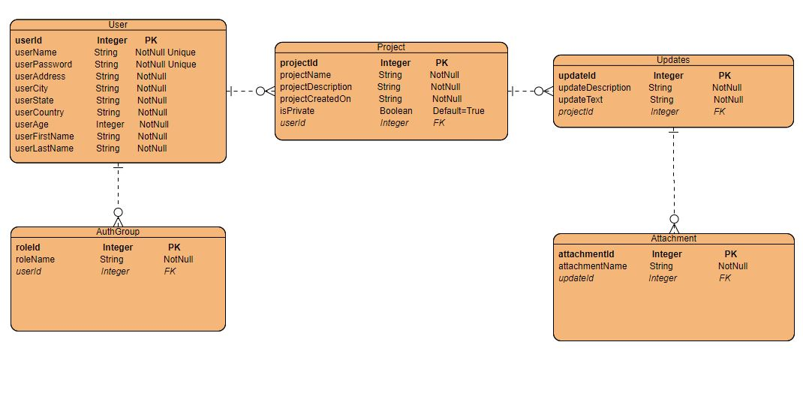

**4. User Stories for Project Journal**

4.1 Epic - As a user, I would like to have a responsive, intuitive website to navigate through the lifecycle of my project.

* Story – As a user, I would like to be able to view my existing projects, select one or create a new project from a convenient view.
* Story – As a user, I would like to be able to edit my projects and create updates to my projects via a project view.
* Story – As a user, I would like to be able to delete my projects or mark them as finished with a final update
* Story – As a user, I would like to be able to view and edit my Account Details from a convenient view.
* Story – As a user, I would like to be able to login to ensure my projects are only managed by myself.

4.2 Epic – As a site owner, I would like to have a robust backend that allows me to handle site requests and provide data to the front end.

* Story – As a site owner, I would like to use mySQL as my database technology.
* Story – As a site owner, I would like to use Spring MVC and Spring Boot to handle requests from my website.